**How to set a default selection for a radio button field in a PDF using C#**

The Syncfusion Essential® PDF is a feature-rich and high performance [**.NET PDF library**](https://www.syncfusion.com/document-processing/pdf-framework/net) used to create, read, and edit PDF documents programmatically without Adobe dependencies. Using this library, you can choose the default value for radio button field in PDF document using C#.

**Steps to choose default value for radio button field in PDF document programmatically:**

1. Create a new console application project.A screenshot of a computer

   AI-generated content may be incorrect.
2. Install the **[Syncfusion.Pdf.Net.Core](https://www.nuget.org/packages/Syncfusion.Pdf.Net.Core" \t "_blank)** NuGet package as a reference to your console application from [**Nuget.org**](https://www.nuget.org/).

1. Include the following namespaces in the Program.cs file.

**C#**

using **Syncfusion**.Pdf.Interactive;

using **Syncfusion**.Pdf;

using **Syncfusion**.Pdf.Graphics;

using **Syncfusion**.Drawing;

1. Use the following code sample in Program.cs to choose default value for radio button field in PDF document.

**C#**

// Create a new PDF document

**PdfDocument** document = **new** **PdfDocument**();

// Add a new page to the PDF document

**PdfPage** page = document.Pages.**Add**();

// Create a new radio button list field

**PdfRadioButtonListField** radioButtonList = **new** **PdfRadioButtonListField**(page, "employeesRadioList");

// Create a font

**PdfFont** font = **new** **PdfStandardFont**(**PdfFontFamily**.Helvetica, 12, **PdfFontStyle**.Regular);

// Create a new radio button item for "Male"

**PdfRadioButtonListItem** radioItem1 = **new** **PdfRadioButtonListItem**("Male");

// Set the bounds for the radio button item

radioItem1.Bounds = **new** **RectangleF**(90, 203, 15, 15);

// Draw the label "Male"

page.Graphics.**DrawString**("Male", font, **PdfBrushes**.Black, **new** **RectangleF**(110, 204, 180, 20));

// Add the radio button item to the radio button list

radioButtonList.Items.**Add**(radioItem1);

// Create a new radio button item for "Female"

**PdfRadioButtonListItem** radioItem2 = **new** **PdfRadioButtonListItem**("Female");

// Set the bounds for the radio button

radioItem2.Bounds = **new** **RectangleF**(205, 203, 15, 15);

// Draw the label "Female"

page.Graphics.**DrawString**("Female", font, **PdfBrushes**.Black, **new** **RectangleF**(225, 204, 180, 20));

// Add the radio button item to the list

radioButtonList.Items.**Add**(radioItem2);

//Set the default selection value index

radioButtonList.SelectedIndex = 1;

// Add the radio button list to the form

document.Form.Fields.**Add**(radioButtonList);

//Save the document into stream.

**MemoryStream** stream = **new** **MemoryStream**();

document.**Save**(stream);

//Close the document.

document.**Close**(true);

// Write the contents of the memory stream to a file

**File**.**WriteAllBytes**("Output.pdf", stream.**ToArray**());

A complete working sample can be downloaded from [**Default\_Value\_For\_Radio\_Button.zip**](https://www.syncfusion.com/downloads/support/directtrac/general/ze/Default_Value_For_Radio_Button543984166.zip)

By executing the program, you will get the PDF document as follows.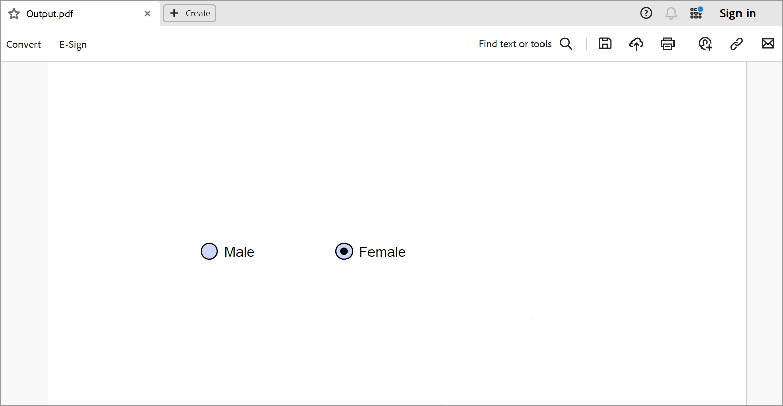

Take a moment to peruse the documentation for [**working with forms**](https://help.syncfusion.com/file-formats/pdf/working-with-forms), where you will find other options like creating, removing, modifying, and filling form fields in PDF document.

Refer [**here**](https://www.syncfusion.com/document-processing/pdf-framework/net)to explore the rich set of Syncfusion Essential® PDF features.